**TEXT -TO-VOICE CONVERSION TOOL**

**Submitted To The**

**SAVEETHA INSTITUTE OF MEDICAL AND TECHNICAL SCIENCES**

**By**

**K. DURGA MANI SANKAR (192372165)**

**Under The Guidance Of**

**Dr. R. GEETHA**

**Professor**



**Institute Of Computer Science and Engineering**

**SAVEETHA SCHOOL OF ENGINEERING CHENNAI-602105 TAMILNADU , INDIA**

**AUGUST 2024**

**TABLE OF CONTENTS**

**S.NO TITLE PAGE NO**

**1 ABSTRACT 3**

**2 INTRODUCTION 4**

**3 MODULES 5**

**4 KEY COMPONENTS 5**

**5 TOOLS DESCRIPITION 7**

**6 ARCHTECTURE DIAGRAM 9**

**7 SOURCE CODE 10**

**8 OUTPUT 11**

**9 FUTURE ENHANCEMENT 12**

**10 CONCLUSION 13**

**ABSTRACT**

**The advanced text-to-voice conversion tool developed in this project aims to transform the way written content is delivered audibly, enhancing accessibility and user interaction. By utilizing cutting-edge natural language processing and machine learning techniques, the tool converts text into natural, expressive speech with remarkable clarity and accuracy.**

**This system offers a highly customizable experience, allowing users to choose from a variety of voice options, accents, and speech rates. Such personalization ensures that the tool can cater to diverse needs, whether for personal enjoyment, educational purposes, or professional use. Users can enjoy a more engaging and tailored auditory experience, suited to their individual preferences and contexts.**

**For developers, the tool provides insightful data on user preferences and behaviors, which can be analyzed to continually refine and enhance the system. This approach supports ongoing innovation and integration with various platforms and applications. Additionally, it opens up potential revenue opportunities through premium features and targeted enhancements based on user feedback.**

**In educational settings, the tool facilitates the conversion of text-based learning materials into spoken word, supporting different learning styles and aiding individuals with visual impairments. It enables educators to create interactive and accessible content, thereby improving teaching efficiency and student comprehension.**

**Overall, this text-to-voice conversion tool represents a significant advancement in auditory technology. It offers a flexible, user-centric solution that enhances accessibility and engagement while providing valuable tools for developers and educators. By bridging the gap between text and speech, it stands to redefine how information is consumed and understood.**

**INTRODUCTION**

**In a world where technological innovations continually reshape our interactions and experiences, the domain of reading has seen transformative changes. The rise of digital platforms has revolutionized access to a vast array of written content, making it easier to explore books, articles, and documents. Despite this wealth of information, navigating and consuming content that matches individual interests and needs can still be a challenge. This is where text-to-voice conversion tools become invaluable.**

**Text-to-voice conversion tools are advanced systems designed to convert written text into spoken words, offering a new dimension to content consumption. These tools utilize cutting-edge technologies such as natural language processing and speech synthesis to produce clear, lifelike speech from textual data. By bridging the gap between text and auditory output, these tools enhance accessibility and engagement for a diverse range of users.**

**Central to text-to-voice conversion is the ability to deliver natural and expressive speech. These tools focus on accurately interpreting the text and converting it into audio that mirrors human speech patterns, including intonation, pace, and emotion. This results in an auditory experience that is both pleasant and comprehensible, making written content more accessible to individuals with visual impairments or those who prefer auditory learning.**

**Customization is a key feature of modern text-to-voice systems. Users can often select from a variety of voices, accents, and speech rates, tailoring the audio output to their personal preferences. This adaptability enhances the listening experience, allowing users to engage with content in a way that suits their individual needs.**

**Integration with other digital platforms further extends the utility of text-to-voice tools. Whether embedded in educational software, productivity applications, or digital libraries, these tools provide seamless access to a wide range of content. They also support various file formats and languages, broadening their applicability across different contexts and regions.**

**Accessibility features are at the forefront of text-to-voice technology, ensuring that it serves a broad audience. From providing support for multilingual content to enabling voice commands and customizable speech settings, these features make the tool inclusive and versatile. By enhancing accessibility, text-to-voice converters empower users with diverse needs, including those with visual impairments or reading difficulties.**

**The data insights generated by text-to-voice systems also offer valuable benefits. By analyzing usage patterns and user preferences, developers can refine and improve the technology, ensuring it remains effective and user-centric. This continuous learning process helps enhance the system’s performance and relevance, contributing to a more personalized and engaging user experience.**

**In summary, text-to-voice conversion tools represent a significant advancement in how we interact with written content. By providing natural, customizable speech output and integrating seamlessly with various platforms, these tools not only enhance accessibility and engagement but also support diverse learning and consumption preferences. They stand as a testament to the ongoing evolution of technology in making information more accessible and enjoyable for everyone.**

**MODULES**

**Modules Used:**

**User Profile Management Module,** **Content Recommendation Module, Natural Language Processing (NLP) Module, Adaptive Learning Module, Interactive Features Module, Context Awareness Module, Feedback and Analytics Module, Integration Module, Security and Privacy Module.**

**KEY COMPONENTS**

**1.User Profile Management:**

* **Voice Preferences: Track user preferences for voice type, speed, pitch, and accent.**
* **History and Usage: Maintain a record of previously converted texts and user interactions with the TTS system.**
* **Personalization: Adapt voice output based on individual user preferences and historical data.**

**2. Content Recommendation Module:**

* **Recommendation Algorithms: Implementation of machine learning or heuristic algorithms to suggest relevant content based on user preferences and behavior**
* **Personalization Engine: Customizes recommendations by analyzing user history and preferences.**
* **Filtering Mechanisms: Utilizes content-based and collaborative filtering methods to refine suggestions.**

**3. Natural Language Processing (NLP) Module:**

* **Text Analysis: Processes and analyzes text to understand context, semantics, and structure.**
* **Entity Recognition: Identifies and categorizes entities such as names, dates, and locations within the text.**
* **Sentiment Analysis: Determines the sentiment or emotional tone of the text to enhance user experience**

**4. Adaptive Learning Module:**

* **Learning Algorithms: Applies algorithms to adapt the system based on user interactions and feedback.**
* **Customization: Modifies system responses and recommendations based on learned user preferences and behavior.**
* **Continuous Improvement: Regularly updates and refines the system based on new data and user feedback.**

**5. Interactive Features Module:**

* **Real-Time Interaction: Supports real-time user interaction, such as voice commands and dynamic content adjustment.**
* **User Engagement Tools: Provides tools for user engagement, such as interactive quizzes, polls, and feedback forms.**
* **Enhanced User Interface: Includes features like interactive buttons and voice commands to improve user interaction.**

**6. Context Awareness Module:**

* **Context Detection: Analyzes the context of user interactions and content to tailor responses and features accordingly.**
* **Adaptive Responses: Adjusts the system’s behavior based on contextual factors such as location, time, and user activity.**
* **Contextual Understanding: Enhances content delivery by understanding and interpreting user context and intent.**

**7. Feedback and Analytics Module:**

* **Feedback Collection: Mechanism for users to provide feedback on their experience and system performance.**
* **Usage Analytics: Tracks and analyzes user behavior, interaction patterns, and system usage metrics.**
* **Performance Reports: Generates reports and insights to evaluate system effectiveness and identify areas for improvement.**

**8. Integration Module:**

* **APIs and Connectors: Facilitates integration with external systems, services, and applications via APIs and connectors.**
* **Data Synchronization: Ensures seamless data exchange and synchronization between the TTS system and other platforms.**
* **Compatibility: Ensures compatibility with various file formats, platforms, and third-party services.**

**9. Security and Privacy Module:**

* **Data Encryption: Encrypts user data and communications to protect against unauthorized access.**
* **Access Controls: Implements user authentication and authorization to control access to sensitive information.**
* **Compliance: Ensures adherence to data protection regulations and industry standards for privacy and security.**

**TOOLS DESCRIPTION**

**1. User Profile Management:**

**Tool: Voice Synthesis Engine**

* **Description: Converts user profile information into spoken words, allowing users to listen to their profile details and settings. Enhances accessibility by providing voice feedback for profile updates and preferences.**

**2.content recommendation system:**

**Tool: Adaptive Text-to-Speech (TTS) Engine**

* **Description: Generates spoken recommendations based on user preferences and interaction history. Customizes voice output to reflect the tone and style of recommended content, improving user engagement through personalized audio cues.**

**3.Natural Language Processing (NLP):**

**Tool: NLP-Driven Voice Synthesis Tool**

* **Description: Integrates with NLP algorithms to convert text derived from natural language understanding into natural, human-like speech. Enables the system to read out complex linguistic constructs, enhancing comprehension and interaction.**

**4.Adaptive Learning Module:**

**Tool: Context-Aware TTS System**

* **Description: Provides adaptive voice feedback based on learning progress and context. Tailors speech output to the learner's current level and needs, offering explanations and instructions in a clear, motivational manner.**

**5. Interactive Features Module:**

**Tool: Real-Time Voice Interaction Engine**

* **Description: Supports interactive features by converting user input into voice responses. Facilitates dynamic conversations and interactive scenarios, enhancing user experience with immediate, contextually relevant spoken replies.**

**6. Context Awareness Module:**

**Tool: Context-Sensitive Voice Generator**

* **Description: Produces voice output that adjusts according to contextual information such as user location, activity, or environment. Ensures that spoken feedback is appropriate and useful in varying contexts.**

**7. Feedback and Analytics Module:**

**Tool: Speech-to-Text Feedback System**

* **Description: Converts user feedback and analytics data into spoken summaries. Helps in reviewing user input and system performance through audio reports, making it easier to digest large amounts of feedback.**

**8. Integration Module:**

**Tool: Cross-Platform TTS API**

* **Description: Provides a standardized interface for integrating text-to-voice capabilities across different modules and platforms. Ensures consistent voice output and simplifies integration efforts with external systems.**

**9. Security and Privacy Module:**

**Tool: Secure Voice Output Engine**

* **Description: Ensures that voice synthesis processes comply with security and privacy standards. Implements encryption and authentication mechanisms to protect sensitive information during voice generation and transmission.**

**ARCHITECTURE DIAGRAM**

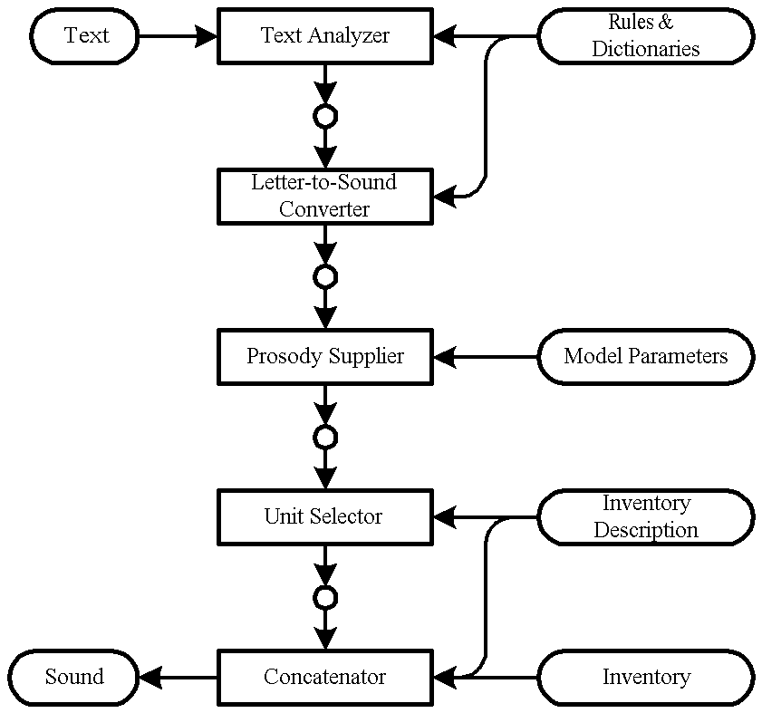

**SOURCE CODE:**

**from gtts import gTTS**

**import os**

**myText=”text to voice conversion”**

**language=’en’**

**output=gTTS(text=myText,lan=language,slow=False)**

**output.save(“output.mp3”)**

**os.system(“start output.mp3”)**

**OUTPUT:**



**FUTURE ENHANCEMENTS**

**1. Advanced Personalization:**

* **Emotionally Adaptive Speech: Adjust tone and pace based on the user’s emotional state.**
* **Predictive Analytics: Anticipate user preferences and adjust voice settings accordingly.**

**2. Enhanced Integration:**

* **Cross-Platform Synchronization: Ensure consistent voice output across all devices.**
* **VR/AR Integration: Use spatial audio for immersive experiences in virtual and augmented reality.**

**3. Dynamic Content Adaptation:**

* **Real-Time Customization: Modify voice output based on user interactions and needs.**
* **Interactive Learning Modules: Adapt voice feedback to learning progress**.

**4. Improved NLP:**

* **Contextual Understanding: Better handle complex queries and provide relevant responses.**
* **Advanced Text Analysis: Offer concise, meaningful summaries of text.**

**5. Social and Collaborative Features:**

* **Collaborative Reading: Enable synchronized voice experiences and shared annotations.**
* **Social Integration: Allow sharing of audio content and reading progress on social media.**

**6. Enhanced Accessibility:**

* **Multi-Sensory Features: Include tactile and auditory feedback for improved accessibility.**
* **Language and Cultural Adaptation: Support diverse accents and languages.**

**7. Ethical and Transparent AI:**

* **Data Control: Provide users with control over their data and voice settings.**
* **Bias Mitigation: Ensure fair and unbiased voice representation.**

**8. Advanced Learning Analytics:**

* **Detailed Insights: Offer analytics on user engagement and performance.**
* **Adaptive Learning Paths: Customize learning journeys based on user progress**.

**CONCLUSION**

**The future of text-to-voice conversion technology is set to revolutionize user interactions through enhanced personalization and adaptability. By incorporating emotional and contextual awareness, systems will tailor voice output to align with users’ moods and situations, providing a more intuitive and engaging experience. Predictive analytics will further refine these interactions by anticipating user preferences and adjusting settings proactively, ensuring a seamless and responsive service.**

**Integration across diverse platforms and devices will enable consistent voice output, creating a unified user experience whether on smartphones, tablets, or virtual reality environments. The addition of immersive technologies like VR and AR will enrich these experiences, making text-to-voice applications more interactive and engaging within virtual spaces.**

**Dynamic content adaptation will allow for real-time adjustments based on user interactions, particularly in educational settings where adaptive voice feedback can support personalized learning. Enhanced natural language processing will improve the accuracy of responses and provide concise, relevant summaries, making interactions with text-to-voice systems more effective and efficient.**

**Ethical considerations will be integral, focusing on transparency, data control, and mitigating biases to ensure fair and inclusive representation. By addressing accessibility needs with multi-sensory features and supporting a diverse range of languages and accents, the technology will offer a more inclusive and personalized experience. This holistic approach will ensure that text-to-voice systems evolve to meet user needs while maintaining high ethical standards.**